Build A Birthday Party Hat Card

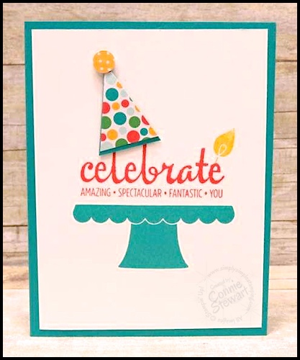
All images © 1990-2016 Stampin’ Up!®

Supplies:
- Stamp Sets – Build A Birthday (138646), Fabulous Four (134174)
- Card Stock – Whisper White (100730), Bermuda Bay (131197)
- Stamp Pads – Bermuda Bay (131171), Crushed Curry (131173), Watermelon Wonder (138323)
- Misc. – Cherry On Top Designer Paper Stack (138443), Dimensionals (104430), Tree Punch (135859), ¼” Circle Punch (134364)

Measurements:
- Bermuda Bay Card Base - 5 ½” x 8 ½”
- Whisper White - 4” x 5 ¼”

Instructions:
- Stamp the cake base in Bermuda Bay ink on the white panel.
- Stamp the greeting in Watermelon Wonder ink.
- Stamp the candle flame on top of the letter “e” in the greeting using Crushed Curry ink.
- Punch designer paper with the Tree Punch. Cut down the piece to eliminate the stem and about ½” of the length so the piece is smaller to resemble a party hat.
- Punch the Bermuda Bay cardstock with the Tree Punch. Cut down the piece to eliminate the stem, about ¼” so the length is just slightly longer than the designer paper cut in step #4.
- Adhere the designer paper to the Bermuda Bay cardstock, leaving a small ‘brim’ of cardstock showing at the bottom.
- Adhere the party hat with Dimensionals.
- Punch a small circle from coordinating designer paper and adhere to the top of the party hat with a small piece of Dimensional. You can substitute the punched piece with a rhinestone, button or other embellishment, if desired.
- Adhere the white panel to the base of the card.

